1. The average of three workers’ salary is 3000

Quantity A Quantity B

The range of three workers’ salary The median of three workers’ salary

1. n is a positive integer

Quantity A Quantity B

The number of the factors of 3

n(n + 1)(n + 2)

1. 10100 = 101000/10n

Quantity A Quantity B

n 10

1. a, b, and c are all even integers, which of the following could be the value of

a2 + b2 + c2 ?

☐56

☐106

☐168

☐286

☐420

1. If a and b are both integers and if 9 < a < 13 and 31 < b < 41, what is the range of a/b?
2. 1/8
3. ¼
4. 3/8
5. 1/6
6. 1/9
7. Jake save cash into 5 different bank accounts. What is the probability that Jade save most into account a and save least into account B?
8. 1/120
9. 1/60
10. 1/80
11. 1/20
12. 1/10
13. A police office will hold an 18-session lesson. For every session, there are 7 days and there is no break between every two sessions. If the session can only be hold on weekdays and if the first session start on Friday, what day is the last day?
14. Mon
15. Tue
16. Wed
17. Thu
18. Fri
19. A linear enzyme is formed by four alpha and two beta protein subunits. How many different arrangements are there?
20. If n is a positive odd integer and r is the remainder when n2 – 1 is divided by 8, the value of r could be

☐0

☐2

☐3

☐5

☐6

1. If two sides of a parallelogram are 6 and 7, what is the area of it?

☐41

☐42

☐43

1. If the product of 5 consecutive integers is not zero, which of following statements individually sufficient provide(s) whether the product of these 5 integers is negative?

☐The greatest number is less than 5

☐At least one of them is less than 0

☐None of them is positive

1. Nuri joins a game for a car. The rule is that Nuri pick one key from box either A, B, or C. A box has two keys but only one can be used. B box has three keys but only one can be used. C box has two keys but none of them can be used. What is the probability that Nuri can win the car?
2. If points (0, 0), (-1, 6), (3, 5) are the vertexes of a parallelogram, how many parallelograms are possible?
3. 1
4. 2
5. 3
6. 4
7. 5

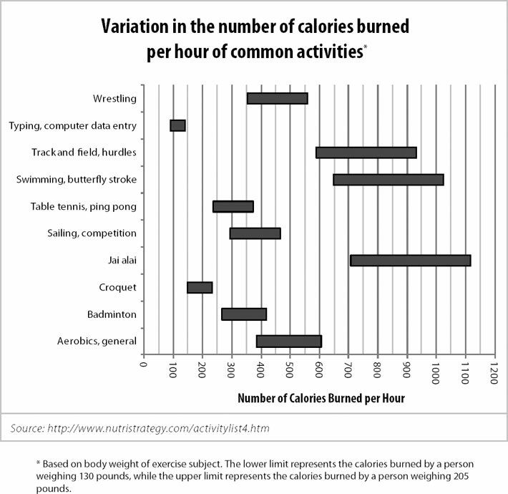

1. Which of the following statements could be true?

☐A person weighing between 130 and 205 pounds performs one of the above activities for 10 hours yet burns fewer calories than another person in the same weight range performing another activity for only 1 hour.

☐A 175-pound person playing Jai Alai for one hour burns fewer calories than a 180-pound person swimming the butterfly stroke for one hour.

☐If all people in question weigh between 130 and 205 pounds, the average calories burned by two people playing table tennis for 1 hour is more than the total calories burned by 2 people typing for 3 hour.

1. Which combination of activities burns the fewest calories total?
2. A 130 pound person playing badminton for 1 hour and a 205 pound person playing table tennis for 1 hour
3. A 130 pound person wrestling for 1 hour and 205 pound person running track and field, hurdles for 1 hour
4. A 130 pound person typing for 1 hour and a 205 pound person swimming the butterfly stroke for 1 hour
5. A 130 pound person sailing in a competition for 1 hour and a 205 person doing aerobics for 1 hour
6. A 130 pound person typing for 1 hour and a 205 pound person playing croquet for 1 hour
7. A and B are graphical representations of normally distributed random variables X and Y, respectively, with relative positions, shapes, and sizes as shown. Which of the following must be true?

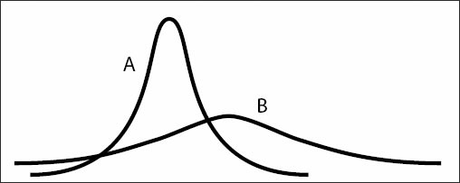

☐Y has a larger standard deviation than X.

☐The probability that Y falls within 2 standard deviations of its mean is larger than the probability that X falls within 2 standard deviations of its mean.

☐Y has a larger mean than X.

1. Right triangle PQR is to be constructed in the xy-plane so that the right angle is at P and PR is parallel to the x-axis. The x and y coordinates of P, Q, and R are to be integers that satisfy the inequalities -4 ≤ x ≤ 5, 6 ≤ y ≤ 16. How many different triangles with these properties could be constructed?
2. 110
3. 1100
4. 9900
5. 10000
6. 12100
7. Which of following equations individually sufficient provide(s) whether U > W?

☐U = |W|

☐W = |U|

☐U > 0

☐W > 0

☐UW > 0

1. In a chemistry course, there are four tests for whole semester. First three tests weigh 20% respectively, and the final test weighs 40%. If Rudy ‘s first three tests’ score 84, 82, and 86, at least how many score he must get in order to be 80 or more for the final grade?
2. 64
3. 74
4. 84
5. 70
6. 75
7. There is an 80% chance David will eat a healthy breakfast and a 25 % chance that it will rain. If these events are independent, what is the probability that David will eat a healthy breakfast or that it will rain
8. 20%
9. 80%
10. 85%
11. 95%
12. 105%

D

A

A

ACE

A

D

E

15

A

AB

ABC

5/18

C

AB

E

AC

C

B

B

C